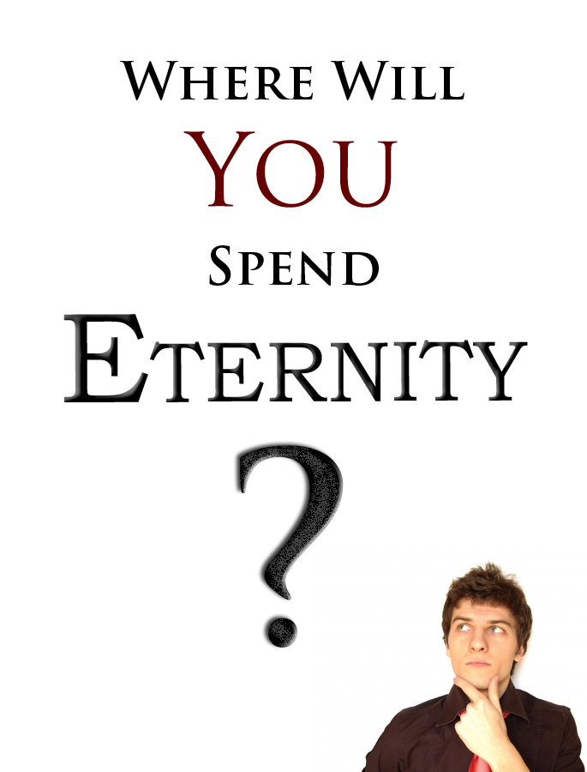
Have you ever thought about your Eternal Future?
Does your Eternal Soul matter to you?
If it does matter, you must know these facts…
- Death Is Certain

Hebrews 9:27 “And as it is appointed unto men once to die, but after this the judgment:”
  - Many people live their life without giving any thought to the afterlife. They live carelessly as if they are never going to die. A simple look at the local graveyard clearly demonstrates that death is just around the corner and will be knocking on your door one day. The question is: “Where Will YOU Spend Eternity”
- Judgment Will Come
Hebrews 9:27 “...but after this the judgment:”

  - The whole world has broken God’s Law – the Ten Commandments; after death everyone will stand before the Judge. The hammer will fall on those that are found in their sins on judgement day and have not fully trusted in Jesus Christ as their Lord and Saviour.
Romans 3:23 “For all have sinned, and come short of the glory of God;”
  - Have you ever lied before? If you have you are a liar. Have you ever stolen anything before? If you have then you are a thief. Have you ever looked upon someone with a lustful desire? If you have, you are an adulterer in heart.
Matthew 5:27-28 “Ye have heard that it was said by them of old time, Thou shalt not commit adultery: vs 28. But I say unto you, That whosoever looketh on a woman to lust after her hath committed adultery with her already in his heart.”
Luke 13:3 “I tell you, Nay: but, except ye repent, ye shall all likewise perish.”
  - If you were standing in the courts of Heaven and were to be judged by God’s law, would you be innocent or guilty? – You would be guilty, of course, because you have broken God’s law.
Hebrews 13:4 “Marriage is honourable in all, and the bed undefiled: but whoremongers (fornicators) and adulterers God will judge.”
  - Please read on and see God’s plan of Salvation - The purpose of Jesus Christ’s death on a Cross. It is against God’s will to see you die in your sin. God desires to save you from your sin and to place you in a relationship with Christ Jesus.
www.gbbc.org.au ~ www.eternal.org.au
- Heaven Is Better

2 Peter 3:9 “The Lord is not slack concerning his promise, as some men count slackness; but is longsuffering to us-ward, not willing that any should perish, but that all should come to repentance.”
  - God’s desire is for every person in the world to be with Him in Heaven. He desires a relationship with them. God loved the world so much He did not want to see anyone go to Hell and perish, including you. The reason people die and go to Hell is because they reject the gift of God – Jesus Christ dying in their place. God became a man to die for you on the Cross. You are a sinner, guilty of breaking the law, but God took your place and became sin (a criminal) for you that you may be free from the judgment to come and that you can be made right with God in His eyes; and, furthermore, so your relationship with God can be restored. Jesus came to give life. Life without God is not life at all. Life with God is Heaven.
2 Corinthians 5:21 “For he hath made him to be sin for us, who knew no sin; that we might be made the righteousness of God in him.”
John 3:36 “He that believeth on the Son hath everlasting life: and he that believeth not the Son shall not see life; but the wrath of God abideth on him.”
  - If you choose not to believe, trust and depend on God with your life then you stand condemned. Remember that you were created by the Creator and for the Creator. Life was given to you by God, and life was intended to be spent with God.
Colossians 1:16 “…all things were created by him, and for him:”

- Hell does Exist
Romans 6:23 “For the wages of sin is death; but the gift of God is eternal life through Jesus Christ our Lord.”
  - Every crime has a penalty. If you break the government’s laws, you will pay the price, whether it is a traffic fine, community service, imprisonment, or the death sentence. In the same way, God has a penalty for sin which is death – not only the physical death but also the spiritual death, separation from God forever in a place called Hell.
Revelations 20:14-15 “And death and hell were cast into the lake of fire. This is the second death. Vs 15 And whosoever was not found written in the book of life was cast into the lake of fire.”
  - If Hell does not exist, why did Jesus die on the Cross? Because the penalty for sin is death. The sufferings of Christ prove that God had to judge sin.
  - Jesus died for sin, so that you do not have to die in your sin.
www.gbbc.org.au ~ www.eternal.org.au
Please, turn over the page
3 Questions
- Do you want to be forgiven, and saved from your sin?
- Are you ready to repent and turn to God?
- Do you want to love and thank God for saving you and spend Eternity with Him?

- Accept the fact that you are a sinner
Romans 3:23 “For all have sinned, and come short of the glory of God;”
- Know that the penalty for sin is death
Romans 6:23 “For the wages of sin is death; but the gift of God is eternal life through Jesus Christ our Lord.”
- Appreciate God’s loving sacrifice for you, though you don’t deserve it
Romans 5:8 “But God commendeth his love toward us, in that, while we were yet sinners, Christ died for us.”
- Believe in Christ’s death, burial, and resurrection and trust Him alone to save you from sin’s penalty
Romans 10:9 “That if thou shalt confess with thy mouth the Lord Jesus, and shalt believe in thine heart that God hath raised him from the dead, thou shalt be saved.”
- Repent from your ways (be truly sorry) and come back to God to do it His way
Acts 3:19 “Repent ye therefore, and be converted, that your sins may be blotted out, when the times of refreshing shall come from the presence of the Lord;”
- Call upon Jesus (in prayer) and God will answer. Ask Him personally to save you from your sin
Romans 10:13 “For whosoever shall call upon the name of the Lord shall be saved.”
  - Salvation is a free gift purchased by the blood of Jesus and offered to anyone who calls upon the Lord with a pure heart asking for mercy and forgiveness.
  - To receive this gift you must ask Jesus by faith to come into your life and save you from your sins. Trust Him alone and nothing else. Will you do it now?
Ephesians 2:8-9 “For by grace are ye saved through faith; and that not of yourselves: it is the gift of God: Not of works, lest any man should boast.”
John 14:6 “Jesus saith unto him, I am the way, the truth, and the life: no man cometh unto the Father, but by me.”
For more information please visit: www.gbbc.org.au

If you have made a decision with all your heart to spend Eternity with God please write to us;
We would like to send you a Bible:
Meeting Place: Maryland Neighbourhood Centre
Address: 207 Maryland Drive, Maryland (Next to Wallsend)
Times: Sunday 10:30am & 5:30pm Wednesday 7:15pm
Contacts: (02) 4016 6420 - info@gbbc.org.au - www.gbbc.org.au

