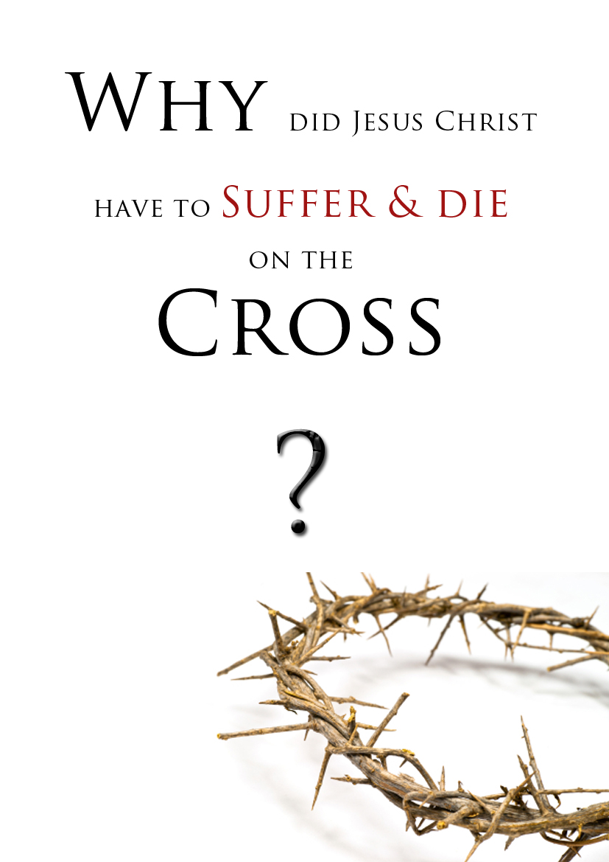

The main reason our Creator – Jesus Christ – came to suffer, die on the Cross of Calvary, and rise again was because of you!

You may ask, “Why did Jesus Christ do that for me”? Well, the sufferings and death of Jesus Christ reveals to us three great and powerful truths.
- God cannot overlook sin!
Sin is actually rebellion against God – disobedience to Him and His commands. Every single person in this world has rebelled against God in some way and has broken some of the Ten Commandments. 1 John 3:4 “Whosoever committeth sin transgresseth also the law: for sin is the transgression of the law.”
Romans 3:10-11 “As it is written, There is none righteous, no, not one: vs 11 There is none that understandeth, there is none that seeketh after God.”

Can you imagine how terrible it is for you to never seek after and love the Creator of this universe Who gave you a life to live? Do you live your own way having no regard for God and His Word, the Bible? Naturally, we’re all proud rebels.
Isaiah 53:6 “All we like sheep have gone astray; we have turned every one to his own way; and the LORD hath laid on him the iniquity of us all.”

Because God is holy, perfectly just and good He cannot disregard our sin. If God were to overlook our sin and not deal with it, then that would make Him an unjust Judge. However, God – the perfect Judge of all the earth – has declared the penalty for our sin. Romans 6:23 “For the wages of sin is death...” Ezekiel 18:20 “The soul that sinneth, it shall die...”
The Bible – God’s Word – speaks of a spiritual death (separation from God), physical death, and “the second death” (separation from God forever in the lake of fire).
Isaiah 59:2 “But your iniquities have separated between you and your God, and your sins have hid his face from you, that he will not hear.”

Revelation 21:8 “But the fearful, and unbelieving, and the abominable, and murderers, and whoremongers, and sorcerers, and idolaters, and all liars, shall have their part in the lake which burneth with fire and brimstone: which is the second death.”

The sufferings and death of Jesus Christ demonstrates to us that God the Father was judging sin. God is “not willing that any should perish,” so He gave us the greatest gift ever given – Jesus Christ dying in our place and receiving judgment for our sin. Romans 6:23 “...the gift of God is eternal life through Jesus Christ our Lord.”
www.eternal.org.au - www.gbbc.org.au

Isaiah 53:5 “But he (Jesus) was wounded for our transgressions, he was bruised for our iniquities: the chastisement of our peace was upon him; and with his stripes we are healed.”

Another powerful truth revealed in the sufferings and death of Jesus Christ is:

- The Reality of Hell!
If Hell does not exist, then why did Jesus Christ suffer and die a brutal death on the cross the way He did? Because, my friend, there is a Hell, and God does not desire you or anyone else to go there. It is against God’s will that you perish in Hell. Hell was created for the fallen, rebellious Angels; but if man-kind decides to follow after Satan’s ways, then it is by their own choice that they go to Hell.

Matthew 25:41 “Then shall he say also unto them on the left hand, Depart from me, ye cursed, into everlasting fire, prepared for the devil and his angels:”

The Bible mentions a true story Jesus told about a rich man who had no regard for God or any desire to heed the voice of God through the prophets that warned against rebellion against God. Notice what happened when he physically died...

Luke 16:23 “And in hell he lift up his eyes, being in torments...”

A Christian man was asked the question, “Can you tell me where Hell is”? After a moment’s hesitation the young Christian said, “Yes, it’s at the end of a Christ-less life.”

John 14:6 “Jesus saith unto him, I am the way, the truth, and the life: no man cometh unto the Father, but by me.”

The only way a person can escape the judgment to come, have sin forgiven, and restore a relationship with God is through the Lord Jesus Christ. No one can get right with God through being a good person, religious rituals, or even trying to keep the Ten Commandments; it is only through faith in the blood of Jesus Christ, the risen Lord.

Ephesians 2:8-9 “For by grace are ye saved through faith; and that not of yourselves: it is the gift of God: vs 9 Not of works, lest any man should boast.”

Galatians 2:21 “I do not frustrate the grace of God: for if righteousness come by the law, then Christ is dead in vain.”

Jesus Christ did not suffer and die in vain. He went through pain and suffering to save you from sin and to restore life to you again. Jesus died like a sinner to save sinners.

Luke 19:10 “For the Son of man is come to seek and to save that which was lost.”
www.eternal.org.au - www.gbbc.org.au
Please turn over
The third powerful truth revealed in the sufferings and death of Jesus Christ is:

- God’s love for you!
What makes God’s love so amazing is that He didn’t have to do what He did. He didn’t have to suffer for you, me and the whole world; He didn’t have to die a cruel death on the cross. But He did it because He loves us so much. God demonstrates true, unconditional love to all humanity.

Romans 5:8 “But God commendeth his love toward us, in that, while we were yet sinners, Christ died for us.”

Jesus Christ, our great God, was not powerless, weak, or defeated, nor did anyone take His life; He willingly gave up His life for all. 1 John 3:16 “Hereby perceive we the love of God, because he laid down his life for us:”

Isaiah 50:6 “I gave my back to the smiters, and my cheeks to them that plucked off the hair: I hid not my face from shame and spitting.”

John 10:11 “I am the good shepherd: the good shepherd giveth his life for the sheep.”

It was not only the nails that held Jesus Christ on the cross. It was His love for you and the whole world. The question is, “What will you do with His amazing love”?

John 3:18 “He that believeth on him is not condemned: but he that believeth not is condemned already, because he hath not believed in the name of the only begotten Son of God.”

Knowing of Jesus is not enough to be saved. Rather, God requires you to turn back to Him (repent) with all your heart and trust in the resurrected Lord Jesus Christ and His finished work on Calvary. Are you willing to pray, telling God you’re sorry for living without Him and asking Him to save you from sin and to give you a home in Heaven?

Romans 10:9 “That if thou shalt confess with thy mouth the Lord Jesus, and shalt believe in thine heart that God hath raised him from the dead, thou shalt be saved.”

Isaiah 55:6-7 “Seek ye the LORD while he may be found, call ye upon him while he is near: vs 7 Let the wicked forsake his way, and the unrighteous man his thoughts: and let him return unto the LORD, and he will have mercy upon him; and to our God, for he will abundantly pardon.”

Romans 10:13 “For whosoever shall call upon the name of the Lord shall be saved.”

If you have made a decision please write to us; we would like to give you a Bible.
Meeting: 25 Thomas St, Cardiff (John Young Community Centre)
Service times: Sundays - 10:30am & 5:30pm
PH: (02) 4016 6420 - Mail: PO Box 318 Kotara, NSW, 2289
Email: info@eternal.org.au Website: www.gbbc.org.au

