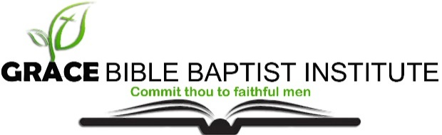
Subject: Evangelism
Date: 22nd May 2018
Lecturer: Charlie Haddad

Quiz 6
Service

Name: ___________________

- Write out the Memory verse: Ephesians 6:12-13
________________________________________________________________________

- As Bible-Believing Christians, we will face three enemies, what are they?

- __________________________________________________________
- __________________________________________________________
- __________________________________________________________

- Please explain the whole armour of God. Christian Soldier's Check-List

- Loins girt about with ______________

_______________________________________________________________________________________________________________________________________

- Breastplate of __________________

_______________________________________________________________________________________________________________________________________

- Feet shod with the preparation of the _______________________

_______________________________________________________________________________________________________________________________________

- Taking the shield of ___________________

_______________________________________________________________________________________________________________________________________

- Helmet of _______________

_______________________________________________________________________________________________________________________________________

- Sword of the Spirit which is ___________________

_______________________________________________________________________________________________________________________________________

- What is the vital element that must be practiced as we put on the whole armour of God?

_________________________________________________________

