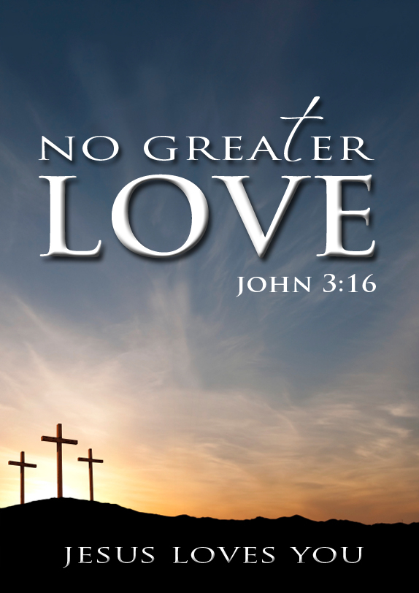

God has amazingly demonstrated to the world the greatest love anyone can ever express. We learn what true love is when we look to God and His Word. Before taking a glimpse at God’s love let us look at some misguided views about God’s love that some in this world have ascribed to Him...

- Misguided Views of God’s Love

Many people today have a false impression about God and His love for the world. Some people think that if God truly loved them, He would tolerate their sinful lifestyle, or meet their expectations and fulfil their own personal desires.
In the very beginning Satan deceived Eve to think that God didn’t love her and that he was holding back by not allowing her to partake of the forbidden fruit.
God’s love is not based on what we think we deserve or what we can get from God; God’s love is based on who He is!
“And the serpent said unto the woman, Ye shall not surely die: For God doth know that in the day ye eat thereof, then your eyes shall be opened, and ye shall be as gods, knowing good and evil.” ~ Genesis 3:1

However God’s love for Eve was evident as He provided Eve with a variety of options to eat from and at the same time warned her not to eat of the fruit that would bring about death in her life. “And the LORD God commanded the man, saying, Of every tree of the garden thou mayest freely eat: But of the tree of the knowledge of good and evil, thou shalt not eat of it: for in the day that thou eatest thereof thou shalt surely die.” ~ Genesis 2:16-17

Along with God’s amazing design in creation comes His authority and leadership; He is God. “Know ye that the LORD he is God: it is he that hath made us, and not we ourselves; we are his people, and the sheep of his pasture.” ~ Psalm 100:3

Once we understand that God is our Creator, and He created us to be dependent; we must wonder that God considered us to be part of His plan and purpose and that He desired a relationship with us - that is great love in itself. Desiring more out of life without God in the picture is both wicked and sinful. “What is man, that thou art mindful of him?...” ~ Psalm 8:4

“What is man, that thou shouldest magnify him? and that thou shouldest set thine heart upon him?” ~ Job 7:17

Some people also falsely believe that if God truly loves them He would not allow all the wars, deaths of innocent children, suffering, hurt, health problems, divorces, etc. However, the truth is that God is blameless and must be cleared of what can only be the result of sin and pride in the heart of man. “For from within, out of the heart of men, proceed evil thoughts, adulteries, fornications, murders, vs 22 Thefts, covetousness, wickedness, deceit, lasciviousness, an evil eye, blasphemy, pride, foolishness:” ~ Mark 7:21-22
www.gbbc.org.au - www.eternal.org.au
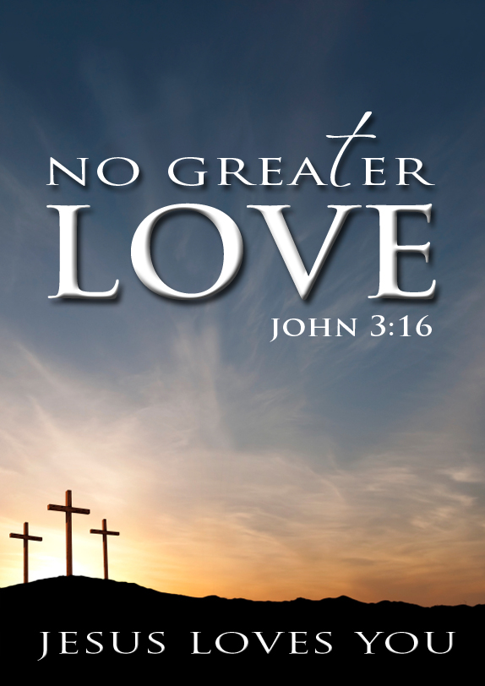
God created all very good – perfect, without sin and death – however, the world now is sin-cursed because of our rebellion against God. Since the Fall in the Garden of Eden, all mankind has inherited this sinful, rebellious nature from Adam and the curse of death has passed upon all men. “Wherefore, as by one man sin entered into the world, and death by sin; and so death passed upon all men, for that all have sinned:” ~ Romans 5:12

We must understand that it is sin that brings forth death. Just as the government is not to be blamed for those who break the law (e.g. a driver who exceeds the 40 km speed limit in a school zone and kills an innocent child), so God is not to be blamed for the choices that we make. Blaming God instead of recognizing the root of the problem – which is sin – will only hinder a person from seeing God’s greatest Love; His wonderful plan of deliverance to save man from the curse of sin, death, and hell.
God certainly cannot be blamed for the sinful decisions and actions people make!

2. A True View of God’s Love

“Greater love hath no man than this, that a man lay down his life for his friends.”
~ John 15:13 - God demonstrated the greatest love by laying down His life for the world. He came down from heaven’s glory; was born of a virgin; was named Jesus (which means Saviour) to die for the sins of the World; He was a king who became a servant; He was rich and He became poor. God proved His great, amazing, unconditional, and wonderful love by wilfully choosing to give His life. He didn’t have to, but He did it because He is a God of true love, and He loves you!

Greater love is to lay down your life for another!

“For God so loved the world, that he gave his only begotten Son, that whosoever believeth in him should not perish, but have everlasting life.” ~ John 3:16
“For ye know the grace of our Lord Jesus Christ, that, though he was rich, yet for your sakes he became poor, that ye through his poverty might be rich.” ~ 2 Cor 8:9
Without God we would never know the true definition of “love.” His “greatest love” - is demonstrated in His sacrificial death. “...for God is love.” 1 John 4:8
Turn page over
www.gbbc.org.au - www.eternal.org.au
Some questions to help you see God’s great love for you.

Was God obligated to give us an opportunity to experience life? No, but He did. God loves you! “And the LORD God formed man of the dust of the ground, and breathed into his nostrils the breath of life; and man became a living soul.” ~ Genesis 2:7

Was God expected to provide food for us to enjoy? No, but He did. God loves you!
“...And the LORD God commanded the man, saying, Of every tree of the garden thou mayest freely eat...” ~ Genesis 2:16-17

Was God required to desire a relationship with us? No, but He did. God loves you!
“Thou art worthy, O Lord, to receive glory and honour and power: for thou hast created all things, and for thy pleasure they are and were created.” ~ Revelation 4:11

Was God compelled to lay down His life and die in our place? No, but He did. God loves you! “Hereby perceive we the love of God, because he laid down his life for us...” ~ 1 John 3:16

Did God have to freely give us all things including a home in Heaven with Him? No, but He did. God has loved us with an everlasting love! “He that spared not his own Son, but delivered him up for us all, how shall he not with him also freely give us all things?” ~ Romans 8:31-32
3. How will you respond to God’s Great Love? Love

Sadly many people will remain under the curse of death, in their sinful state, and be separated from God forever because of their choice to reject God and His love. But what will you do with the Lord Jesus Christ – the one who died on the cross for your sin and rose again the third day? Will you call upon Him now with ALL your heart and ask Him to save you from your sinful ways, to restore life to you again and to give you a home in Heaven to be with God the Father forevermore?

Will you pray now with all your Heart by,
- Admitting you’re a sinner.
- Acknowledging that the penalty of sin is death.
- Repenting & Believing on Jesus Christ to save you from your sin.
- Thanking the Lord Jesus for laying down His life for you & making you His child.

“Behold, what manner of love the Father hath bestowed upon us, that we should be called the sons of God: therefore the world knoweth us not, because it knew him not.” ~ 1 John 3:1
Meeting Place: Maryland Neighbourhood Centre
Address: 207 Maryland Drive, Maryland (Next to Wallsend)
Times: Sunday 10:30am & 5:30pm Wednesday 7:15pm
Contacts: (02) 4016 6420 - info@gbbc.org.au - www.gbbc.org.au

