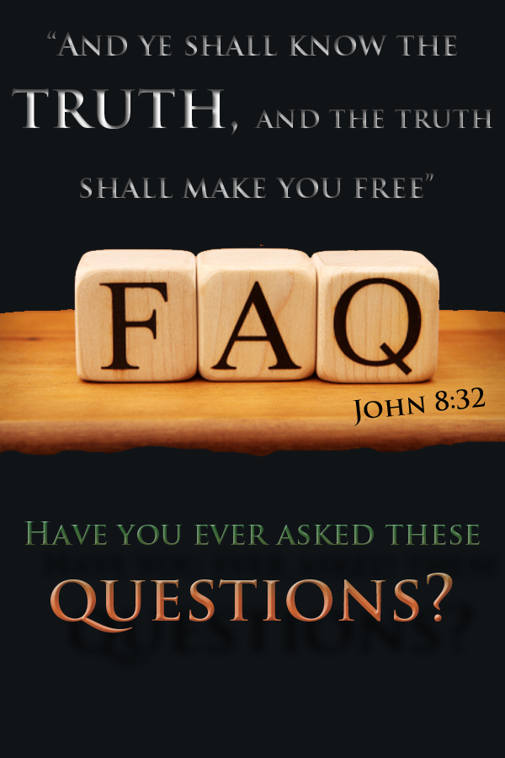

- How do you know the Bible is true? It was written by men.
www.gbbc.org.au ~ www.eternal.org.au
MOST COMMON QUESTIONS
2 Peter 1:21 “For the prophecy came not in old time by the will of man: but holy men of God spake as they were moved by the Holy Ghost.”
- Holy Men of God were like pens in the hand of God.
- Prophecy in the Bible proves the Word of God to be true.
2Peter 1:21 ~ 1 John 1:1-2 ~ 2 Timothy 3:16 ~ Deuteronomy 18:21-22
- The Bible has been changed so many times. Why should I trust the Bible?
Proverbs 30:5 “Every word of God is pure: he is a shield unto them that put their trust in him. vs 6 Add thou not unto his words, lest he reprove thee, and thou be found a liar”
- The Bible has not changed, people are the ones who try to add to it and take away from it.
- God promised to preserve His Word from generation to generation.
Genesis 3:1 ~ Proverbs 30:5-6 ~ Psalm 12:6-7 ~ Psalm 119:89
- Is not Christianity all about making money? They just want my money.
2 Peter 2:1, 3 “But there were false prophets also among the people, even as there shall be false teachers among you, vs 3 ... And through covetousness shall they with feigned words make merchandise of you:”
- The Bible itself warns us about such people that will try to profit from the truth. Judas Iscariot was one of those people.
- Will you allow the sins of others to get your eyes off the truth?
2 Peter 2:1-4 ~ John 12:4-6 ~ Philippians 1:15-18
- What happens to all the people who have not heard the gospel?
Matthew 24:14 “And this gospel of the kingdom shall be preached in all the world for a witness unto all nations; and then shall the end come.”
- God’s desire is that all hear the gospel and come back to Him through Jesus Christ.
- Has not God allowed you to hear the Gospel today? What makes you think that He is not reaching others?
2 Peter 3:9 ~ Matthew 24:14 ~ 1 Timothy 4:10
- I don't believe that God exists; I cannot see Him.
Romans 1:20 “For the invisible things of him from the creation of the world are clearly seen, being understood by the things that are made, even his eternal power and Godhead; so that they are without excuse:”
- God does not want anyone to be without excuse; He has manifested Himself through Creation, Conscience and His Word.
Romans 1:20 ~ Psalm 19:1 ~ Psalm 14:1 ~ John 4:24 ~ Genesis 1:1
- Why does God allow people/children to suffer?
Romans 5:12 “Wherefore, as by one man sin entered into the world, and death by sin; and so death passed upon all men, for that all have sinned:”
- God’s creation was very good – perfect and without blemish, sin and death
- The world now is sin-cursed because of the rebellion against God.
- God cannot be blamed for the sinful actions of people. Man-kind needs to take responsibility for their own free-will choices in life.
Genesis 1:31~ Genesis 2:16-17 ~ Romans 5:12 ~ Romans 8:16-18, 28
- What happens to little children when they die? Where do they go?”
Matthew 19:14 “But Jesus said, Suffer little children, and forbid them not, to come unto me: for of such is the kingdom of heaven.”
- Little children/infants will be in Heaven.
Matthew 18:3 ~ Matthew 19:14 ~ 2 Samuel 12:21-23
- If God created all things, then who created God?
Jude 1:25 “To the only wise God our Saviour, be glory and majesty, dominion and power, both now and ever. Amen.”
- God always existed and is the One with all power; He is the Almighty.
- Do you think your created mind is able to comprehend The Creator?
Genesis 1:1 ~ 1 Corinthians 2:7 ~ 2 Timothy 1:9 ~ Jude 1:25 ~ Psalm 90:2
- Why would such a loving God send people to Hell?
2 Peter 3:9 “The Lord is not slack concerning his promise, as some men count slackness; but is longsuffering to us-ward, not willing that any should perish, but that all should come to repentance.”
- If man-kind decides to continue to live in rebellion against God and does not repent, then they are making their own choice to follow after Satan.
- If people choose to reject God and not receive His gift, whose fault is it?
Matthew 25:41 ~ John 3:17-18 ~ 2 Peter 3:9 ~ Ezekiel 33:11
- How can Jesus be God?
John 8:58 “Jesus said unto them, Verily, verily, I say unto you, Before Abraham was, I am.”
- Jesus was sinless ~ Creation obeyed Jesus ~ Jesus is the Creator
- Jesus didn't have to say He was God in the flesh, His life proved it.
- There are many verses in the Scriptures that prove Jesus is God the Son.
Isaiah 9:6 ~ John 8:58 ~ John 1:1, 14 ~ 1 Timothy 3:16 ~ Colossians 1:16 ~ John 20:28
- How Can someone know for sure they can go to Heaven?
www.gbbc.org.au ~ www.eternal.org.au
Philippians 1:21 “For to me to live is Christ, and to die is gain.”
- Many of Christ’s followers (true disciples) had assurance of their Salvation.
John 11:26-27 ~ 1 John 5:10-13 ~ Philippians 1:21-23 ~ 2 Corinthians 5:8
- Do you want to be forgiven, and saved from your sin?
- Are you ready to repent and turn to God?
- Do you want to love and thank God for saving you, and spend Eternity with Him?

- Accept the fact that you are a sinner
Romans 3:23 “For all have sinned, and come short of the glory of God;”
- Know that the penalty for sin is death
Romans 6:23 “For the wages of sin is death; but the gift of God is eternal life through Jesus Christ our Lord.”
- Appreciate God’s loving sacrifice for you, though you don’t deserve it
Romans 5:8 “But God commendeth his love toward us, in that, while we were yet sinners, Christ died for us.”
- Believe in Christ’s death, burial, and resurrection and trust Him alone to save you from sin’s penalty
Romans 10:9 “That if thou shalt confess with thy mouth the Lord Jesus, and shalt believe in thine heart that God hath raised him from the dead, thou shalt be saved.”
- Repent from your ways, be truly sorry, and come back to God to do it His way
Acts 3:19 “Repent ye therefore, and be converted, that your sins may be blotted out, when the times of refreshing shall come from the presence of the Lord;”
- Call upon Jesus (in prayer) and God will answer. Ask Him personally to save you from your sin
Romans 10:13 “For whosoever shall call upon the name of the Lord shall be saved.”
  - Salvation is a free gift purchased by the blood of Jesus and offered to anyone that calls upon the Lord with a pure heart asking for mercy and forgiveness.
  - To receive this gift you must ask Jesus by faith to come into your life and save you from your sins. Trust Him alone and nothing else. Will you do it now?
Ephesians 2:8-9 “For by grace are ye saved through faith; and that not of yourselves: it is the gift of God: Not of works, lest any man should boast.”
John 14:6 “Jesus saith unto him, I am the way, the truth, and the life: no man cometh unto the Father, but by me.”
For more information please visit: www.gbbc.org.au - If you have made a decision with all your heart to spend Eternity with God please write to us, we would like to send you a Bible.
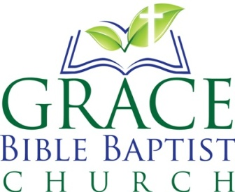
Meeting Place: Maryland Neighbourhood Centre
Address: 207 Maryland Drive, Maryland (Next to Wallsend)
Times: Sunday 10:30am & 5:30pm Wednesday 7:15pm
Contacts: (02) 4016 6420 - info@gbbc.org.au - www.gbbc.org.au

